LOT  adasdasdasd | sadasdad  sadasd  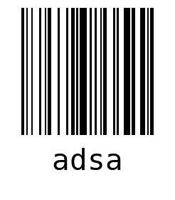  WO dsas  LOT adasdasdasd  QTY 20
asdads
asdasa
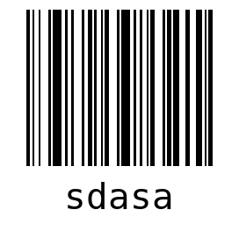
WO asdas
LOT adasdasdasd
QTY 20

SHEET  1 | sadasdad  sadasd  WO dsas  LOT adasdasdasd
sadasdad  sadasd  WO dsas  LOT adasdasdasd | sadasdad  sadasd  WO dsas  LOT adasdasdasd
sadasdad  sadasd  WO dsas  LOT adasdasdasd | sadasdad  sadasd  WO dsas  LOT adasdasdasd

sadasdad  sadasd  WO dsas  LOT adasdasdasd | sadasdad  sadasd  WO dsas  LOT adasdasdasd
sadasdad  sadasd  WO dsas  LOT adasdasdasd | sadasdad  sadasd  WO dsas  LOT adasdasdasd
sadasdad  sadasd  WO dsas  LOT adasdasdasd | sadasdad  sadasd  WO dsas  LOT adasdasdasd

sadasdad  sadasd  WO dsas  LOT adasdasdasd | sadasdad  sadasd  WO dsas  LOT adasdasdasd
sadasdad  sadasd  WO dsas  LOT adasdasdasd | sadasdad  sadasd  WO dsas  LOT adasdasdasd
sadasdad  sadasd  WO dsas  LOT adasdasdasd | sadasdad  sadasd  WO dsas  LOT adasdasdasd

sadasdad  sadasd  WO dsas  LOT adasdasdasd | sadasdad  sadasd  WO dsas  LOT adasdasdasd
sadasdad  sadasd  WO dsas  LOT adasdasdasd | asdads  asdasa  WO asdas  LOT adasdasdasd
SHEET  2 | asdads  asdasa  WO asdas  LOT adasdasdasd

asdads  asdasa  WO asdas  LOT adasdasdasd | asdads  asdasa  WO asdas  LOT adasdasdasd
asdads  asdasa  WO asdas  LOT adasdasdasd | asdads  asdasa  WO asdas  LOT adasdasdasd
asdads  asdasa  WO asdas  LOT adasdasdasd | asdads  asdasa  WO asdas  LOT adasdasdasd

asdads  asdasa  WO asdas  LOT adasdasdasd | asdads  asdasa  WO asdas  LOT adasdasdasd
asdads  asdasa  WO asdas  LOT adasdasdasd | asdads  asdasa  WO asdas  LOT adasdasdasd
asdads  asdasa  WO asdas  LOT adasdasdasd | asdads  asdasa  WO asdas  LOT adasdasdasd

asdads  asdasa  WO asdas  LOT adasdasdasd | asdads  asdasa  WO asdas  LOT adasdasdasd
asdads  asdasa  WO asdas  LOT adasdasdasd | asdads  asdasa  WO asdas  LOT adasdasdasd
asdads  asdasa  WO asdas  LOT adasdasdasd | asdads  asdasa  WO asdas  LOT adasdasdasd

